Planning my portfolio

The audience-my portfolio will be aimed at the people at konnected.

Purpose- the purpose of creating a portfolio is that people can see what kind of work you’ve done and companies can check also and see if your suitable for the job.

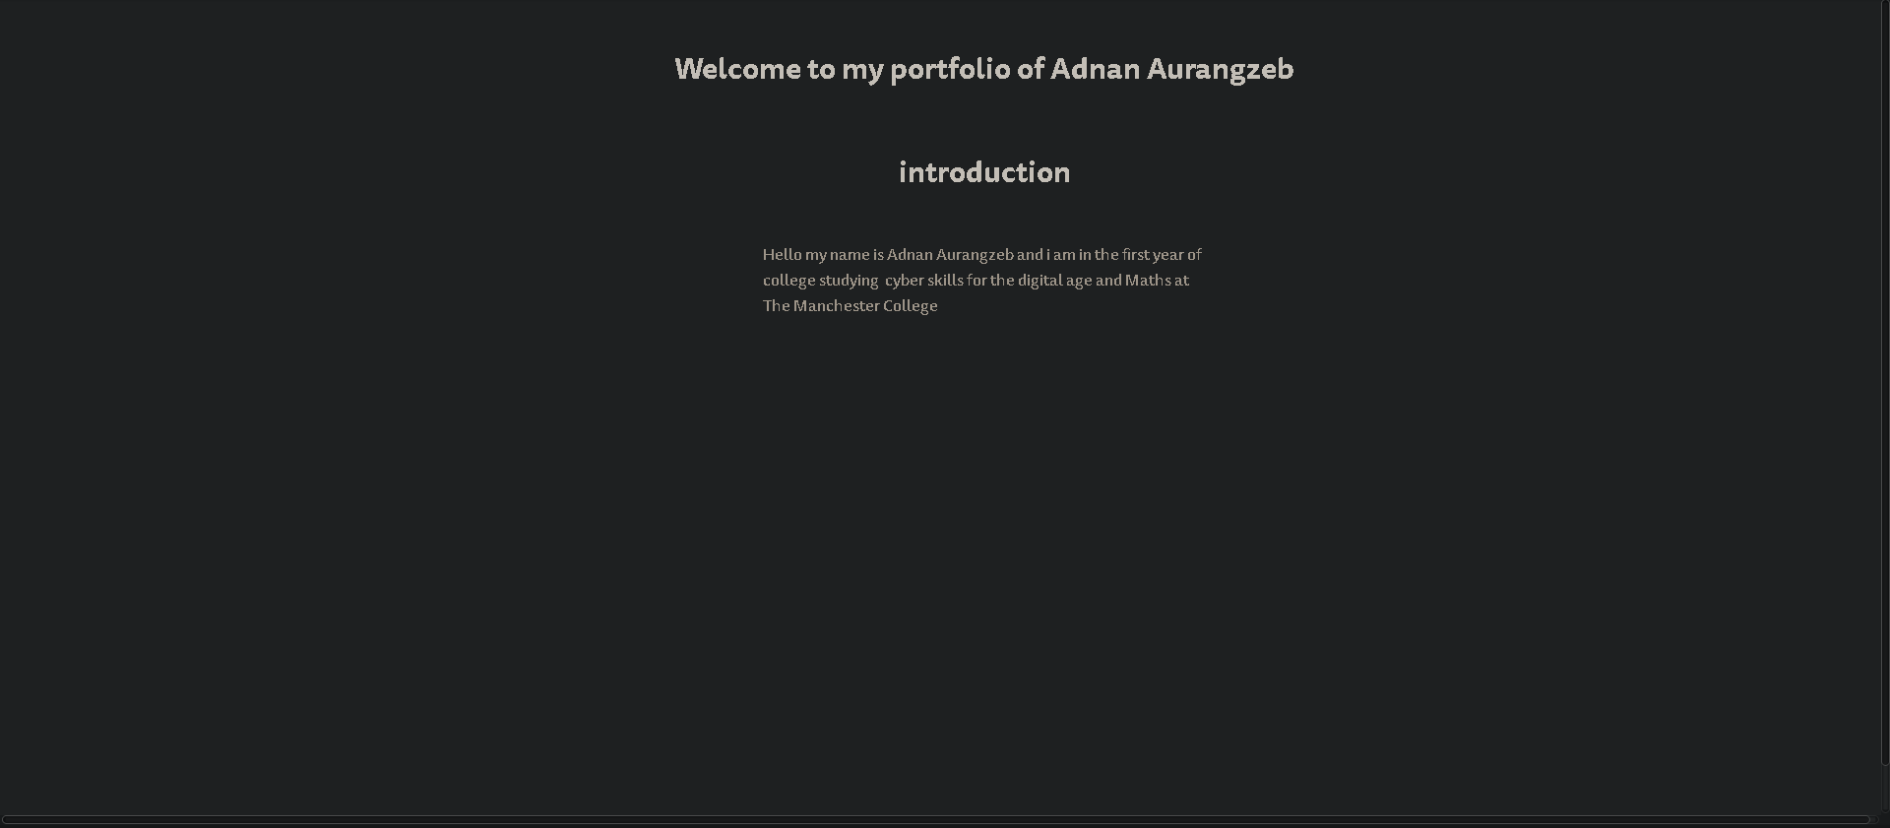

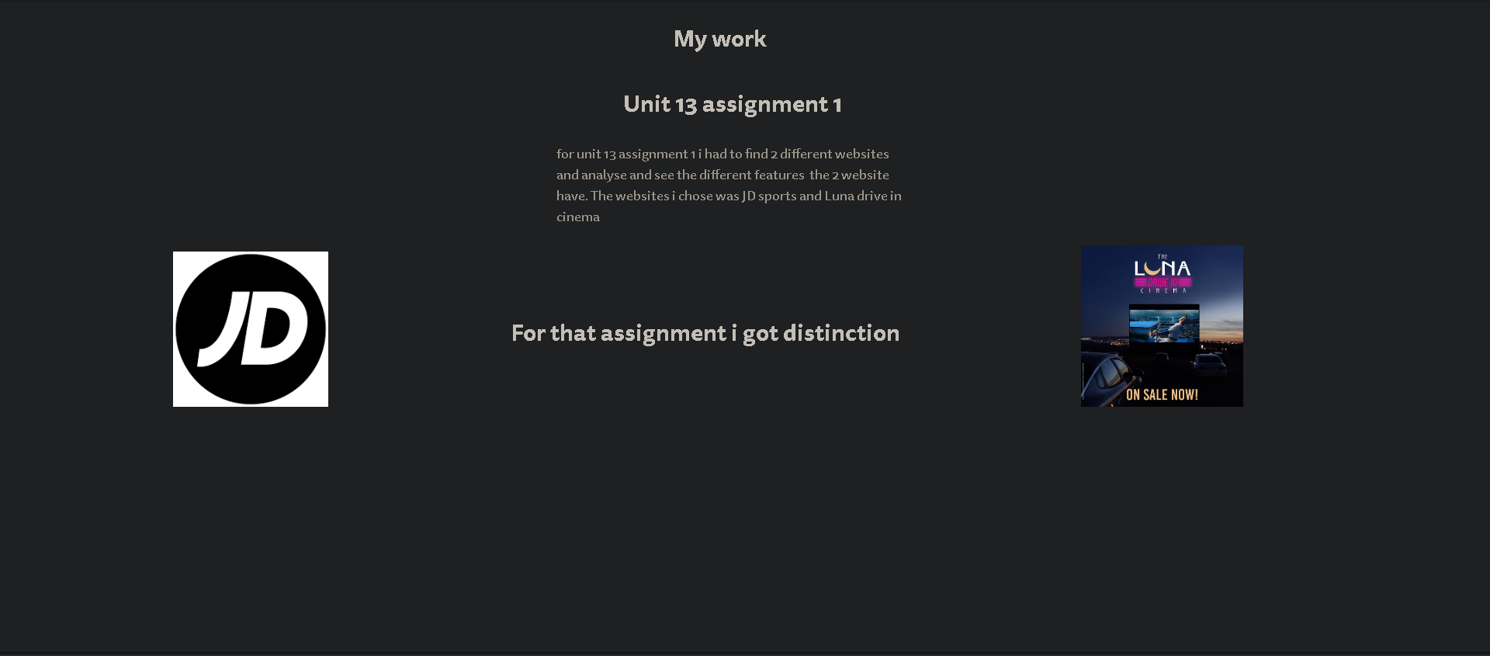

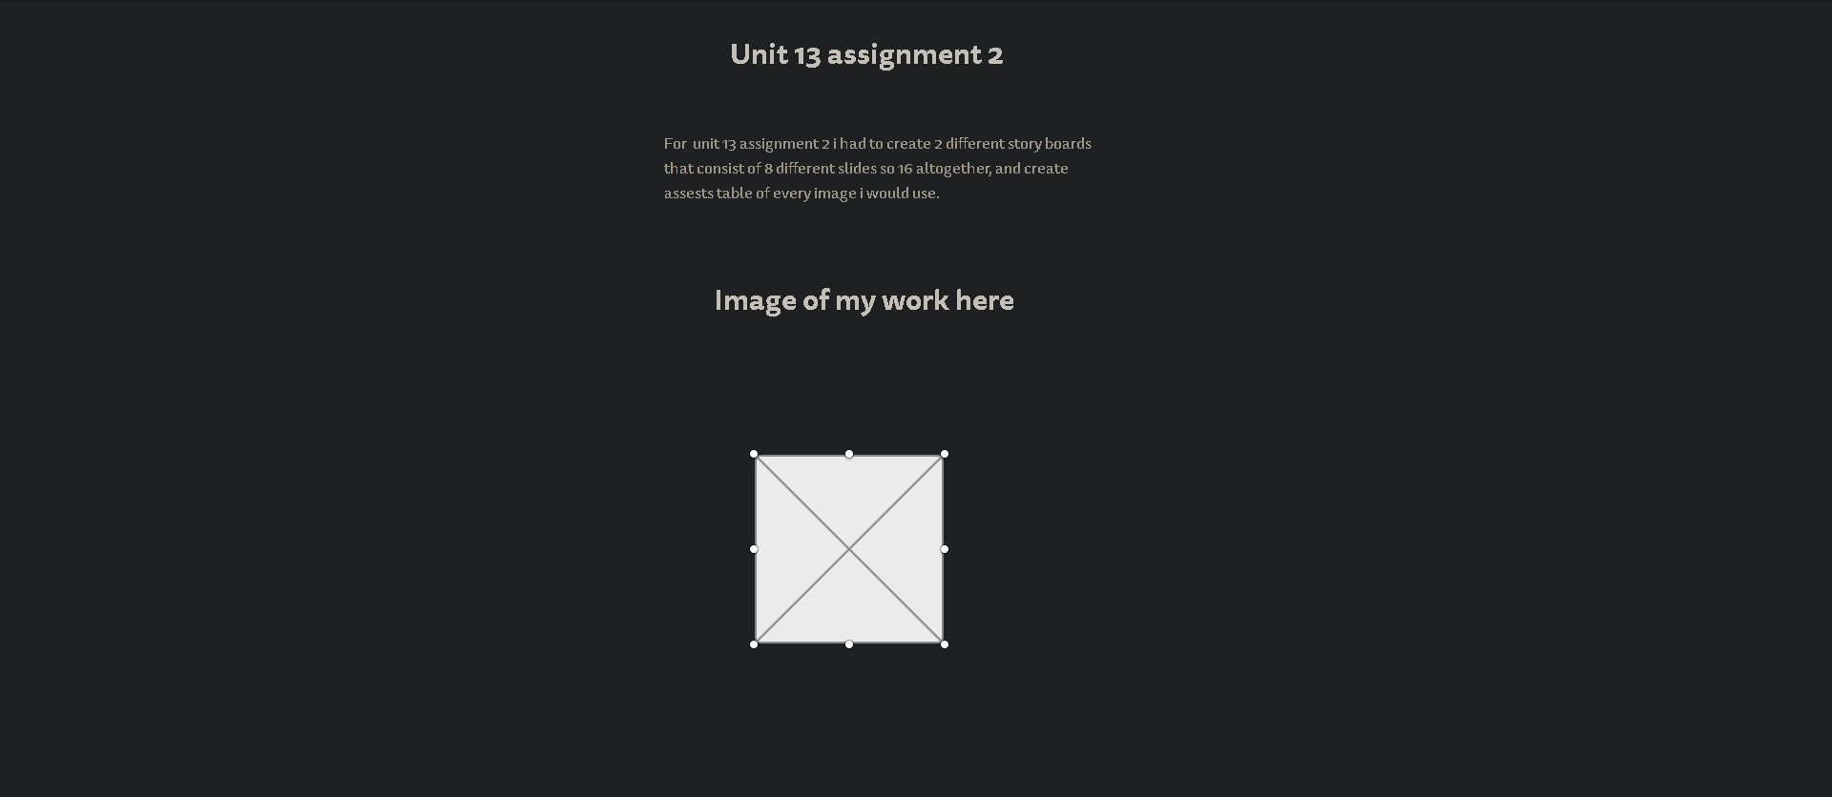

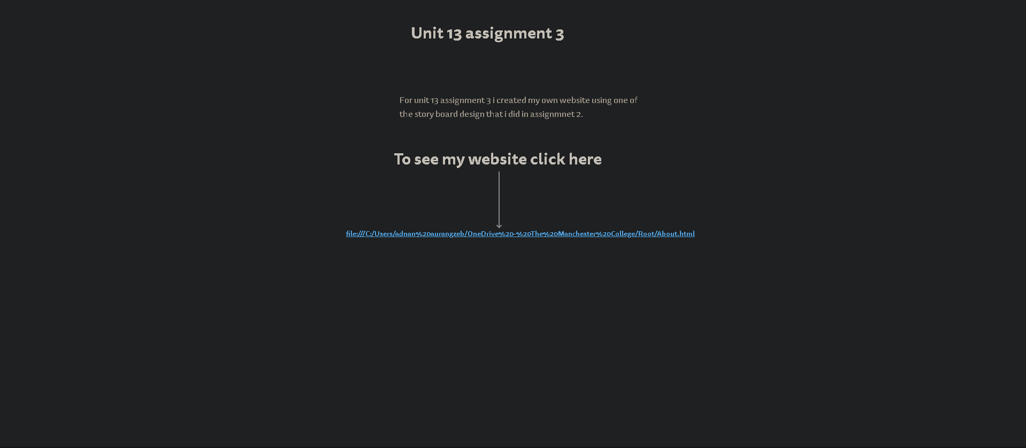

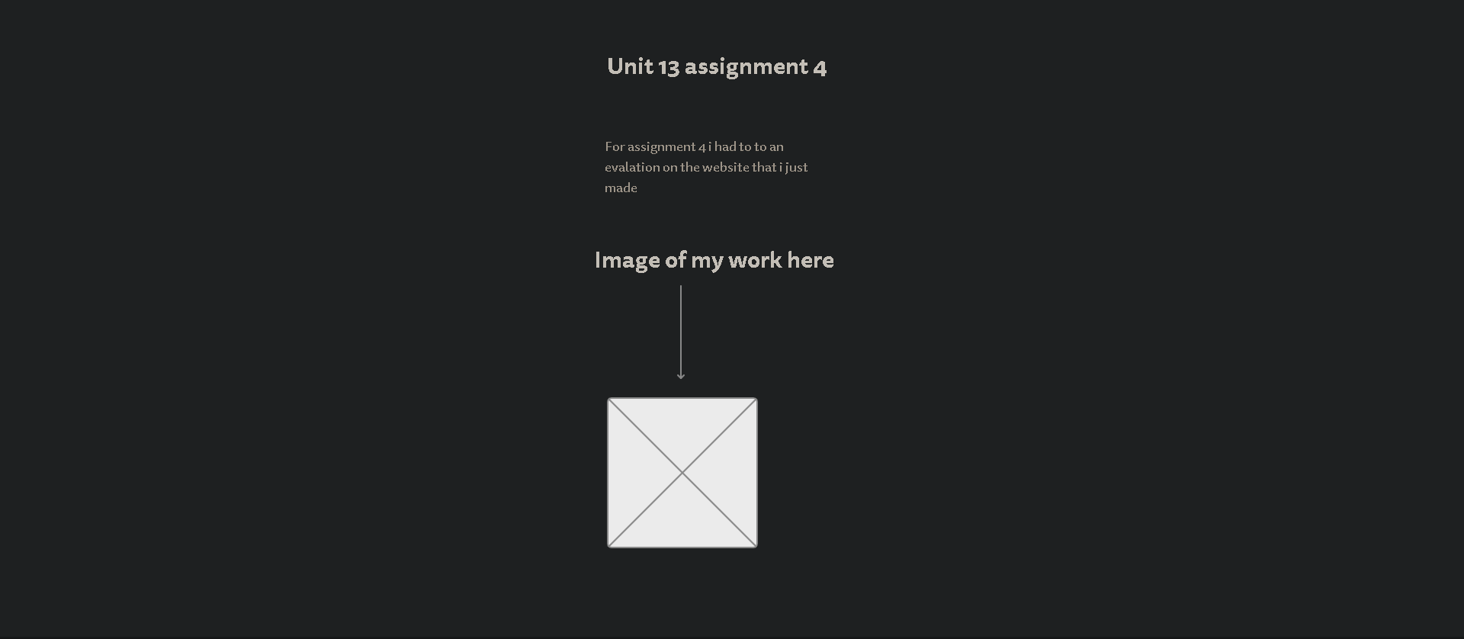

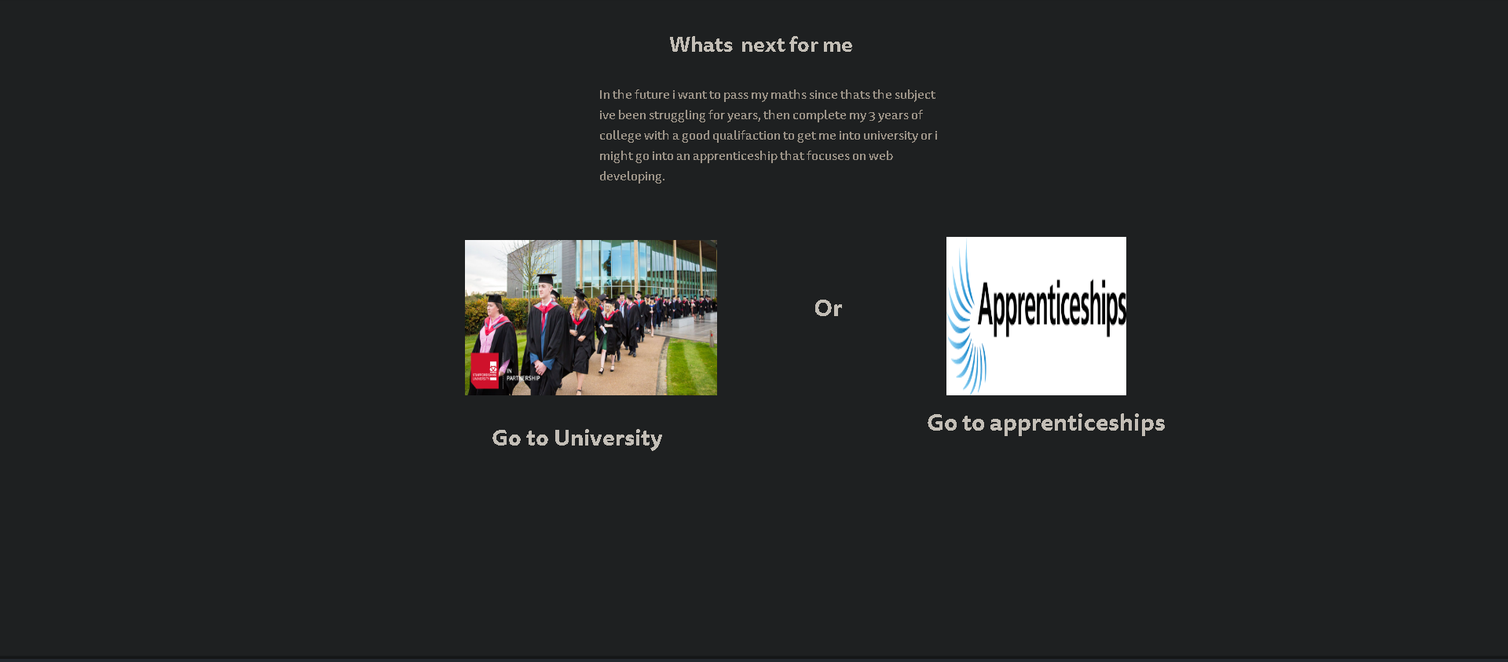

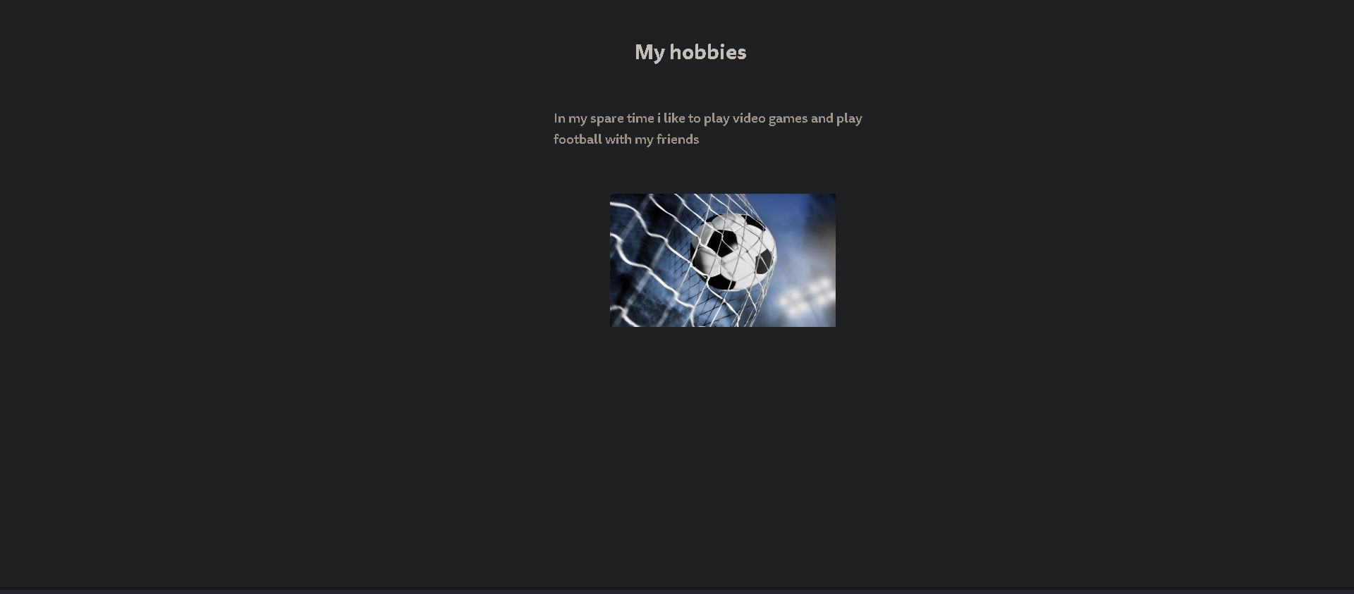

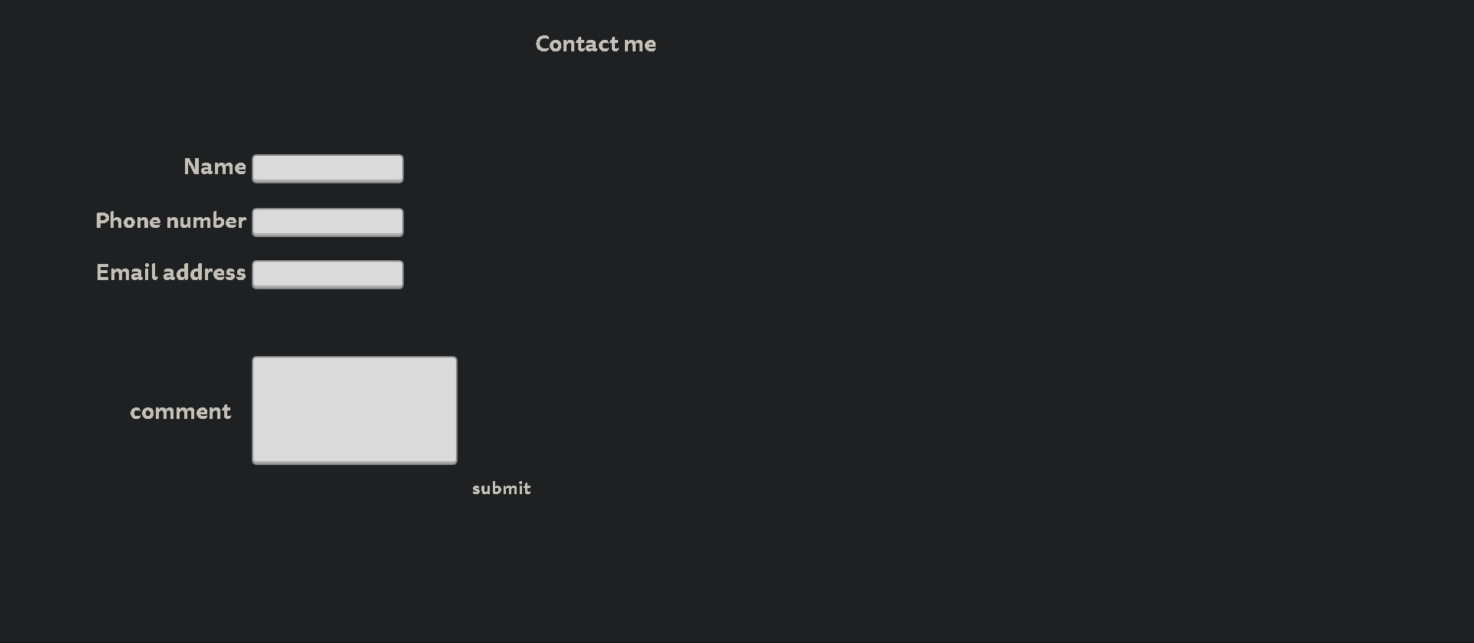

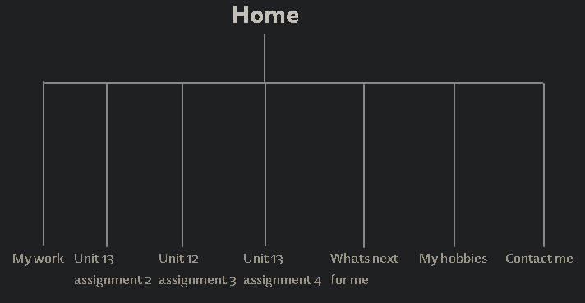

|  |  |  |  |  |  |
| --- | --- | --- | --- | --- | --- |
| Name of asset | Description of asset | Image/link | Ready-made/original | Created by | To be used on page... |
| JD | A logo made for JD |  | Ready made | google | My work |
| Luna drive in cinema | A logo made for Luna drive in cinema |  | Ready made | google | My work |
| Assignment 2 | Work on teams |  | Ready made | me | Unit 13 Assignment 2 |
| Assignment 3 | Work on teams | file:///C:/Users/adnan%20aurangzeb/OneDrive%20-%20The%20Manchester%20College/Root/About.html | Ready made | me | Unit 13 assignment3 |
| Assignment 4 | Work on teams |  | Ready made | me | Unit 13 Assignment 4 |
| University | Picture of university students |  | Ready made | google | What's next for me |
| Apprenticeships | Logo |  | Ready made | Google | What's next for me |
| football | Picture of a football |  | Ready made | Google | My hobbies |

Alternative story board

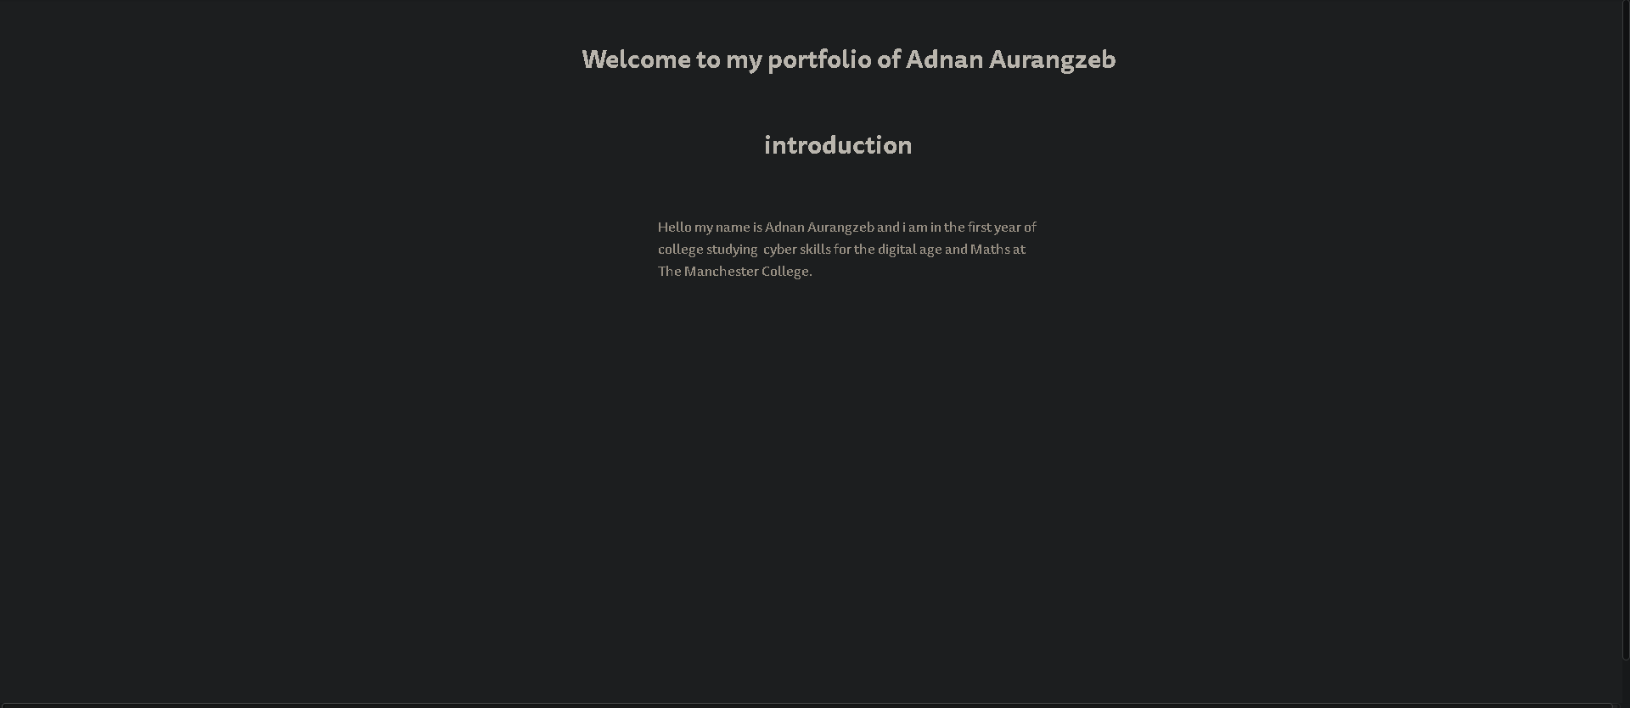

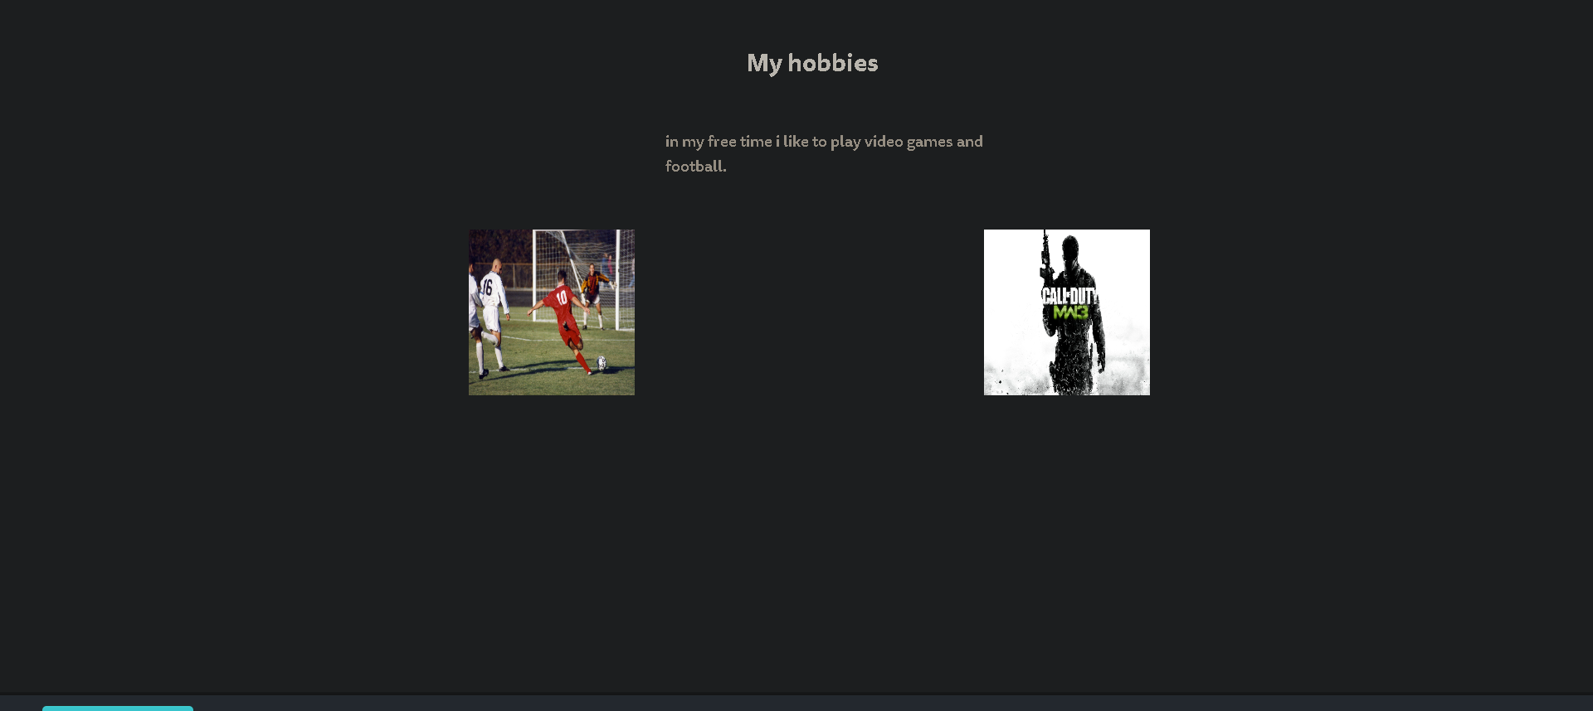

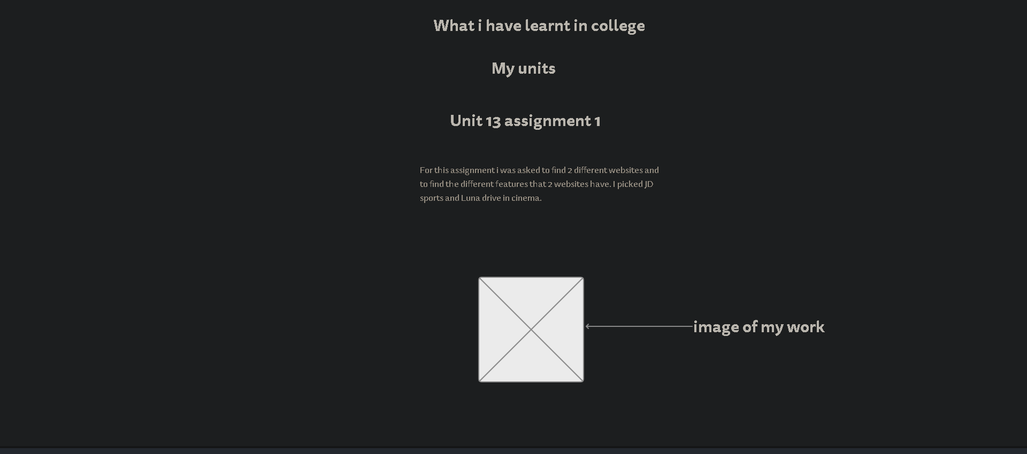

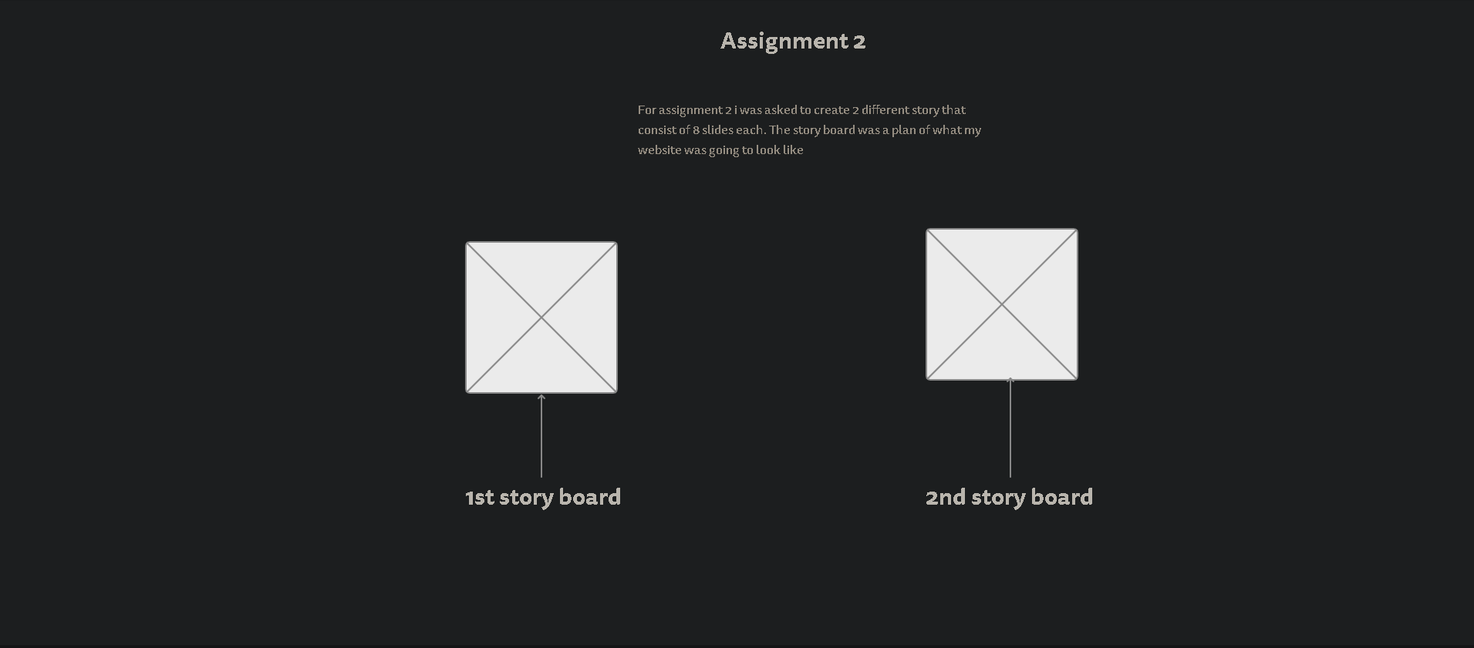

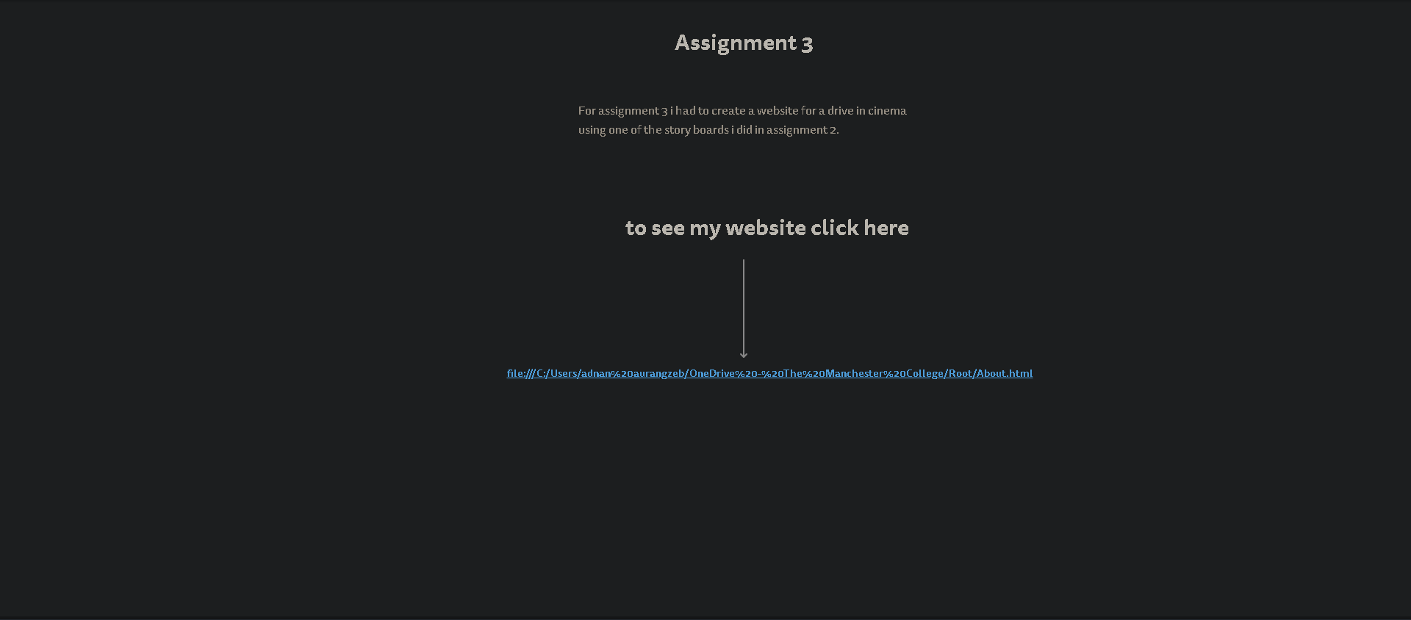

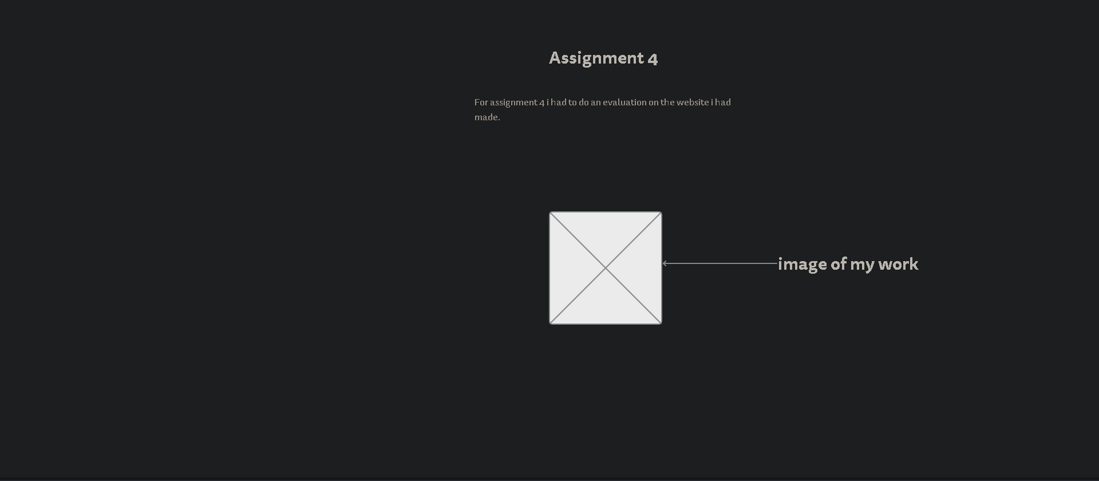

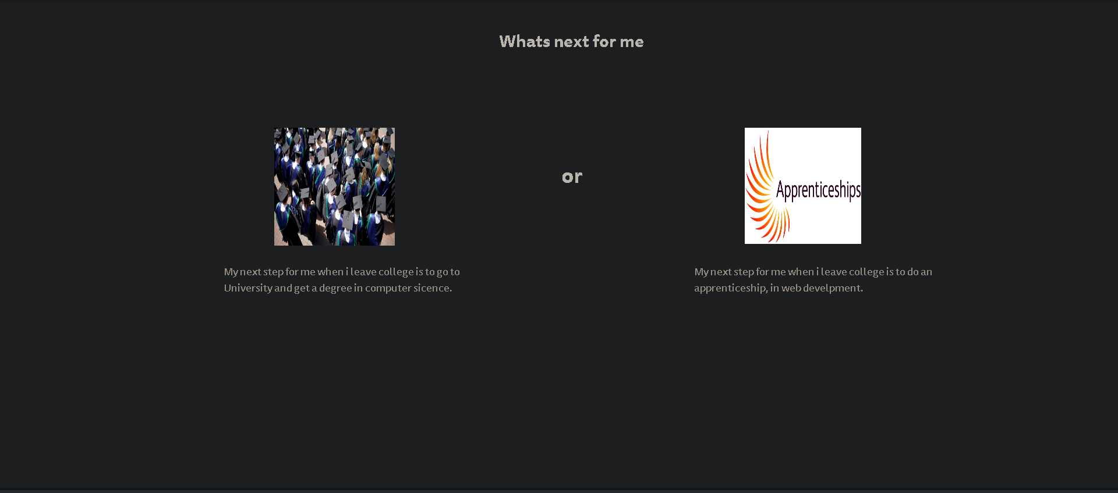

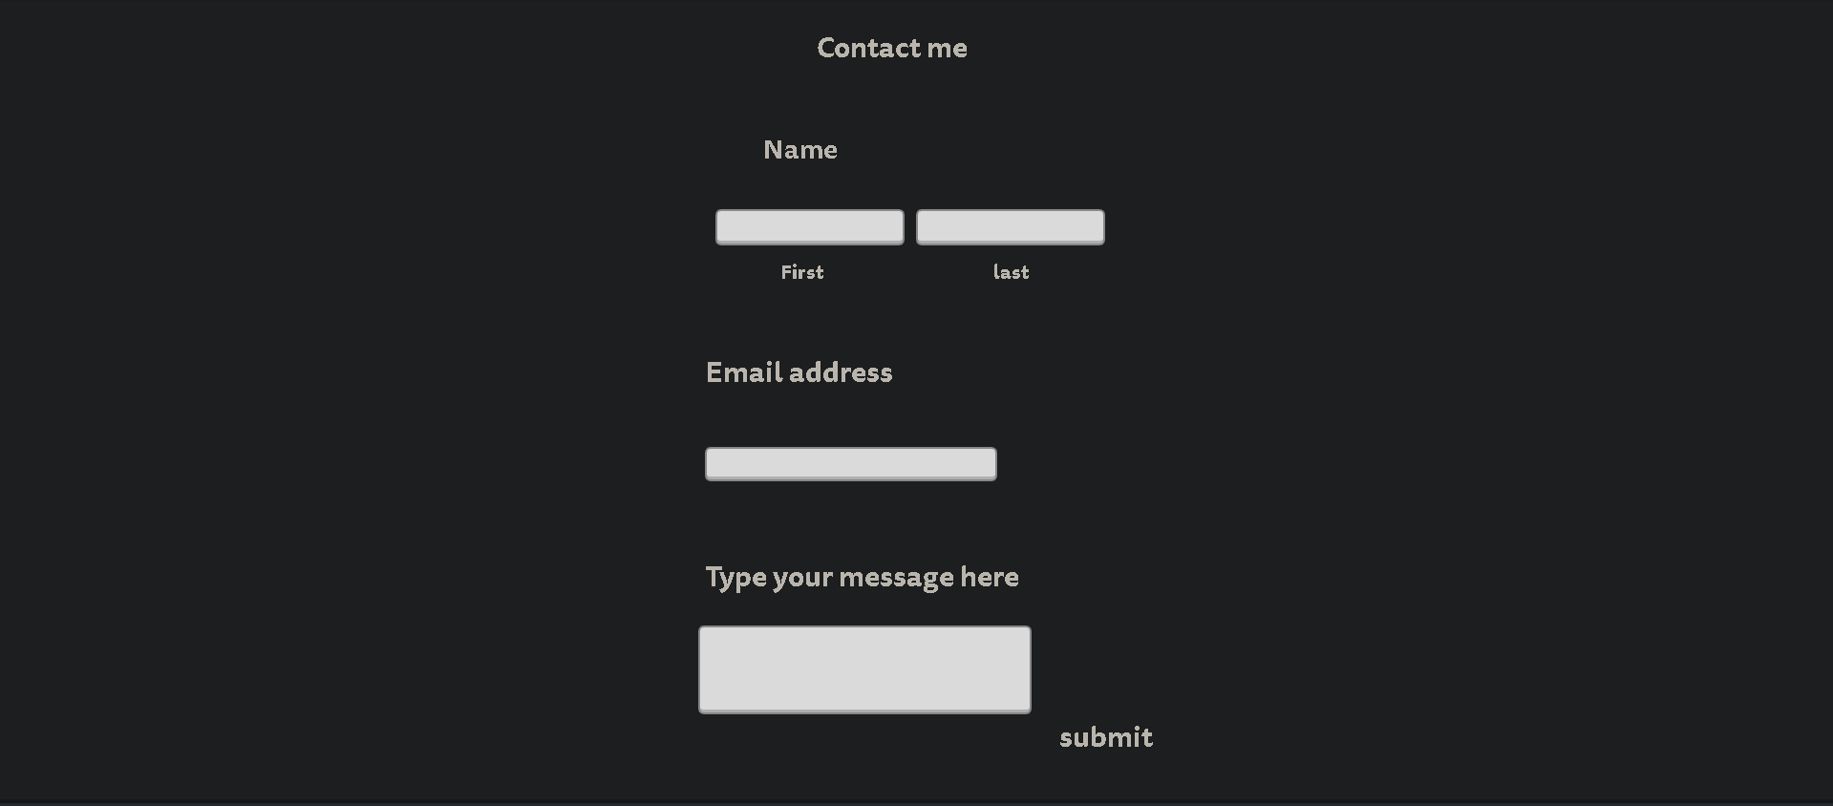

Sitemap

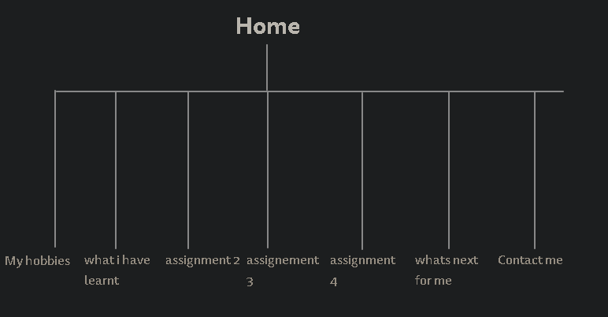

|  |  |  |  |  |  |
| --- | --- | --- | --- | --- | --- |
| Name of asset | Description of asset | Image/link | Ready-made/original | Created by | To be used on page... |
| football | Someone kicking a football |  | Ready made | google | My hobbies |
| mw3 | Logo made for mw3 (video game) |  | Ready made | google | My hobbies |
| Assignment 1 | Work on teams |  | Ready made | me | What I have learnt in college |
| Assignment 2 | Work on teams |  | Ready made | me | Assignment 2 |
| Assignment 2 | Work on teams |  | Ready made | me | Assignment 2 |
| Assignment 3 | Work on teams | file:///C:/Users/adnan%20aurangzeb/OneDrive%20-%20The%20Manchester%20College/Root/About.html | original | me | Assignment 3 |
| Assignment 4 | Work on teams |  | original | me | Assignment 4 |
| University | Picture of uni students |  | Ready made | Google | What's next for me |
| Apprenticeships | logo |  | Ready made | Google | What's next for me |

**Fulfil the stated purpose**

My Portfolio will fulfil the stated purpose because, my portfolio has assignments and work that will impress the people at konnected, and the different skills I have to work at a tech company.

**Meets the needs of the audience**

My portfolio meets the need of the audience because, on my portfolio it will have my assignments that I have done and also have information about myself, so this meets the audience because, my portfolio is not made for an engineering company but for a tech company because, my work Is based on computing. Also, my portfolio is well presented so it is not made for fun but made for professional companies to see so it is well represented.